ML Systems Optimization
Group Assignment
Parallelised Deep Learning for Image Classification
CIFAR-10 Dataset | ResNet-18 | PyTorch DDP | Data Parallelism

BITS Pilani — Work Integrated Learning Programme (WILP)
Course: ML Systems Optimization

1. Problem Formulation
This section defines the parallelisation strategy, establishes measurable performance targets, and justifies the approach based on dataset and workload characteristics.

Parallelisation and/or distribution strategy: We have chosen Kaggle as our experiment environment, which provides maximum of 2 GPUs.
Environment specifications:
- Platform: Kaggle
- GPU model: NVIDIA T4
- Number of GPUs: 2 GPUs
- VRAM: ~16 GB per GPU
- Architecture: Turing

The CIFAR-10 datasets fit entirely in RAM (~614 MB), which gets stored in the RAM after 1 epoch. Hence it should not involve I/O operations which increases the communication overhead.
We are using a variant of ResNet18 as our Model with below

Total params: 11,173,962
Trainable params: 11,173,962
Non-trainable params: 0
Total mult-adds (Units.MEGABYTES): 555.43
============================================================================================================================================
Input size (MB): 0.01
Forward/backward pass size (MB): 9.83
Params size (MB): 44.70
Estimated Total Size (MB): 54.54

Each gradient sync transfers ~44 MB (11M params × 4 bytes),
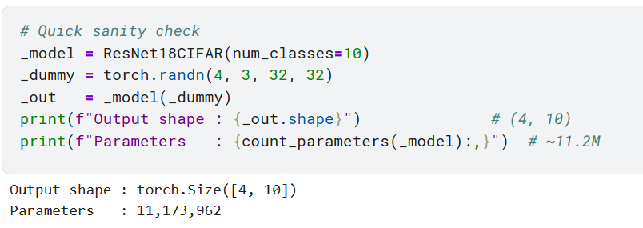
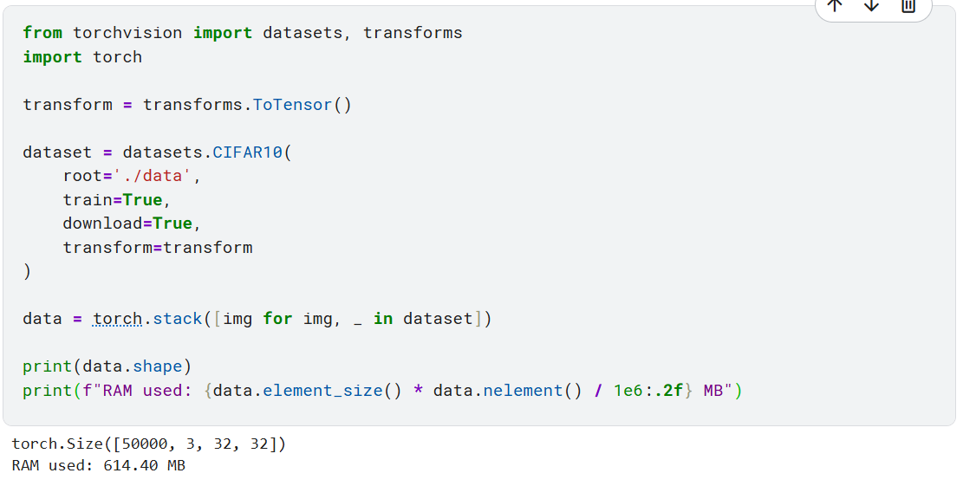

So there will only be a modest communication burden relative to the compute per batch, making data parallelism the natural choice over model or pipeline parallelism
We have chosen Pytorch DDP Framework for

Metrics

Justification on the Approach based on dataset and workload characteristics :

